**AWS Advanced Projects (Day5-Day6)**

**========================================**

**PROJECT 1:**

**Working with IAM Roles with S3 and bootstrapping with EC2**

**Task 1:** Creating a bootstrapped instance

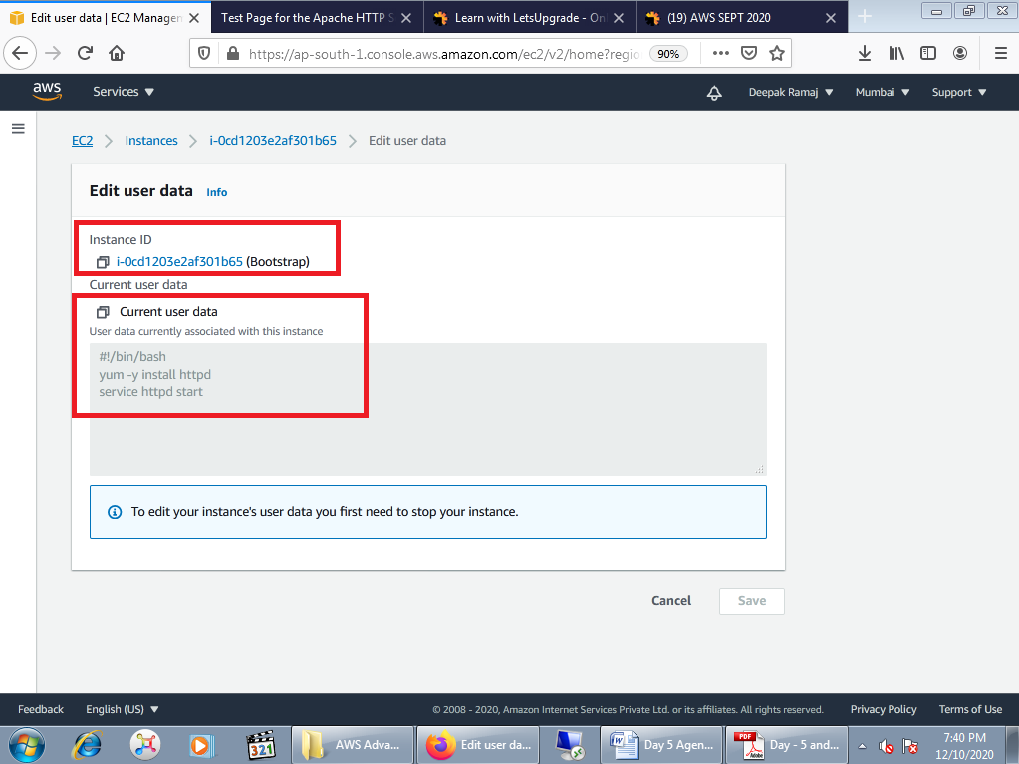

Fig. 1.1.1 User Data screen

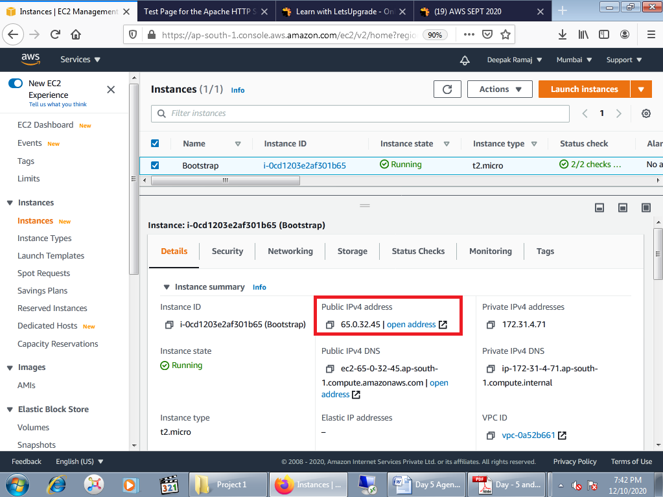

Fig. 1.1.2 EC2 Dashboard

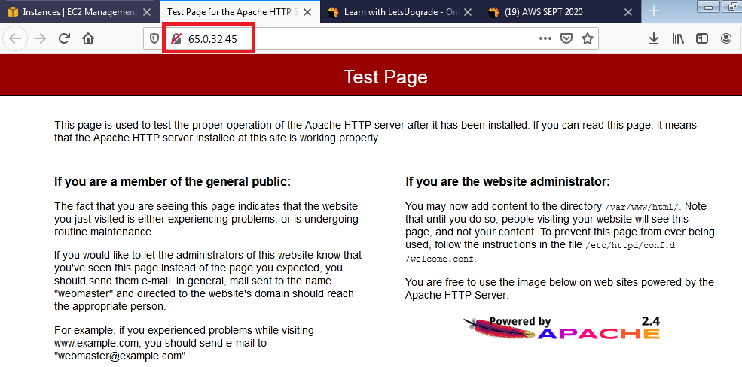

Fig. 1.1.3 Test Page

**Task 2:** Checking bucket list and creating a new bucket from EC2 using IAM Roles

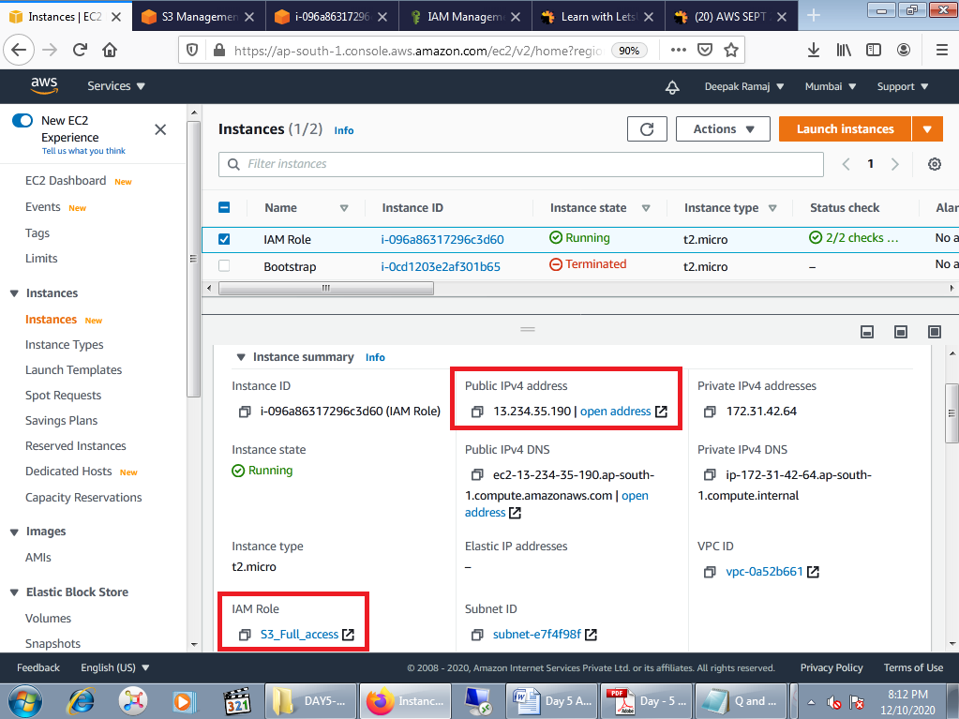

Fig. 1.2.1 EC2 Dashboard

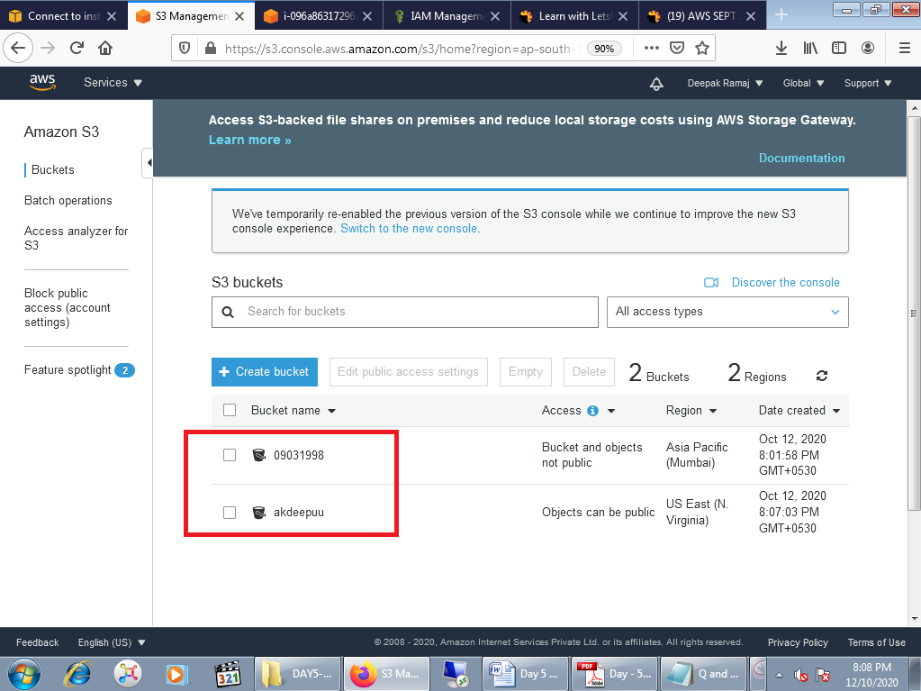

Fig. 1.2.2 Amazon S3 Bucket

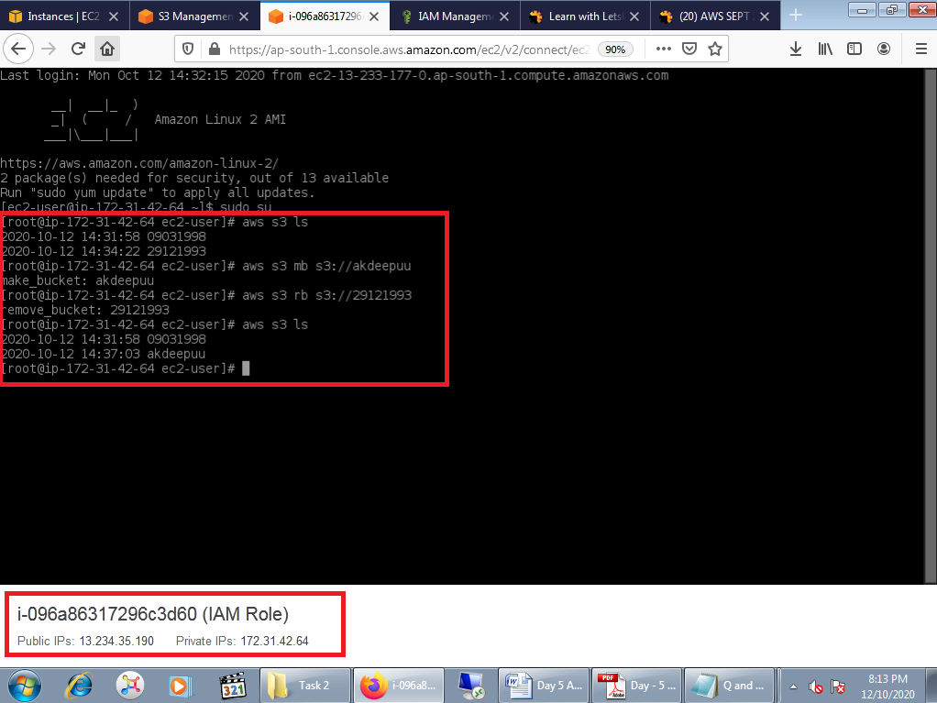

Fig. 1.2.3 Commands executed

**Task 3:** Hosting a webpage using the bootstrap script on ec2

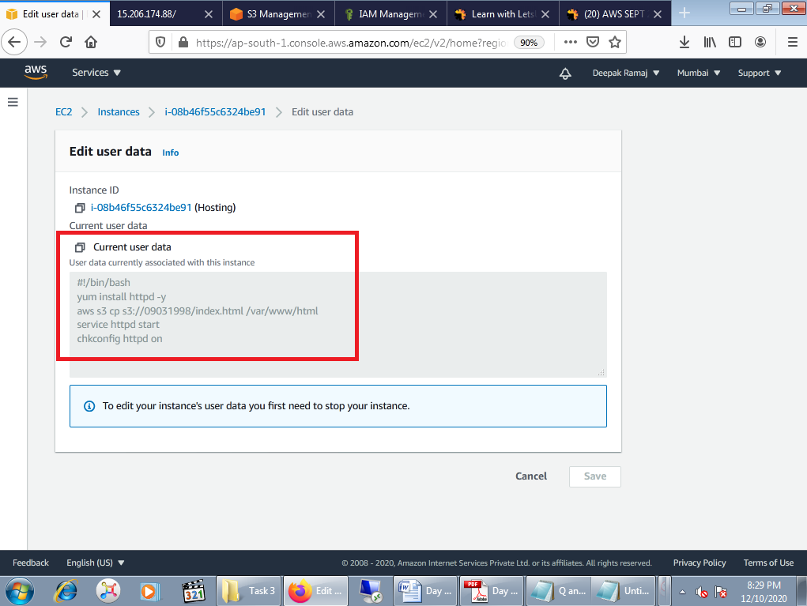

Fig. 1.3.1 User Data

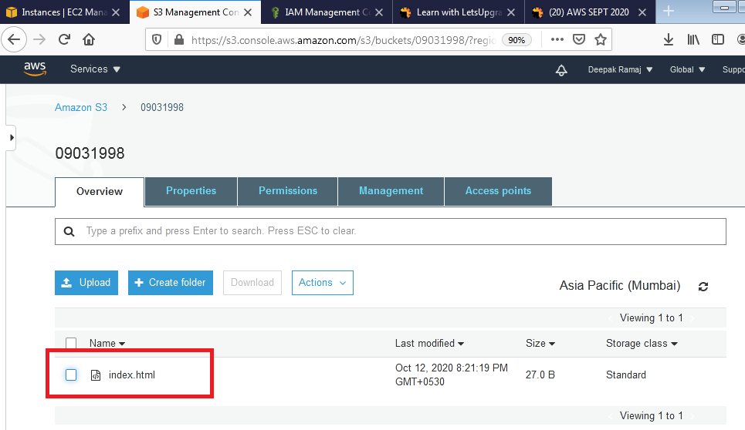

Fig. 1.3.2 Amazon S3 Bucket

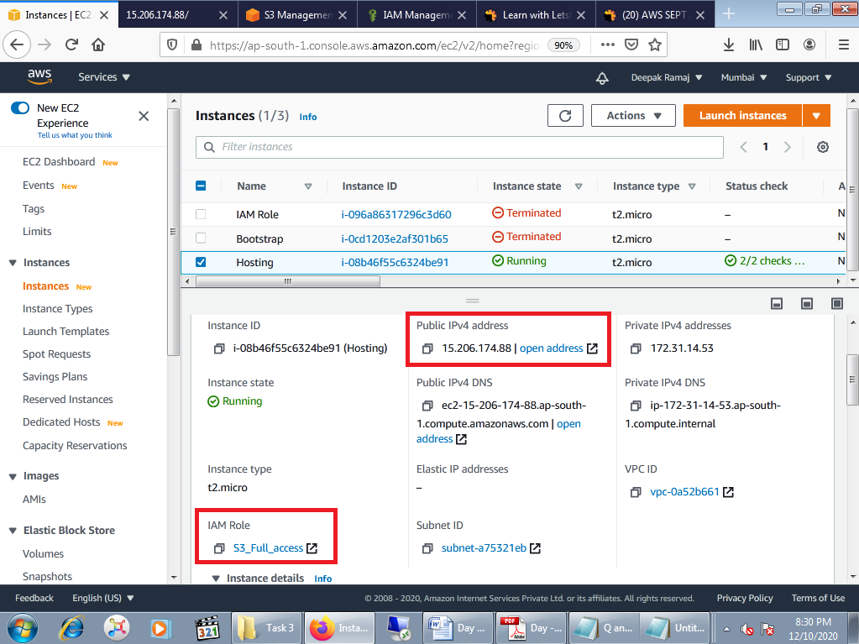

Fig. 1.3.3 EC2 Dashboard

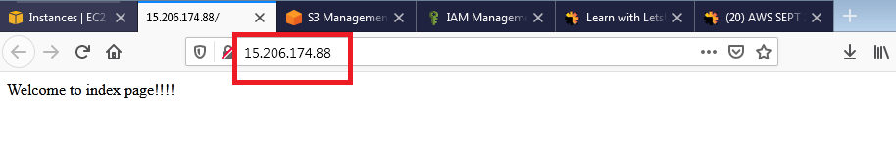

Fig. 1.3.4 index.html webpage

**PROJECT 2: Creating an EC2 instance in custom VPC**

**Task 1:** Create a VPC

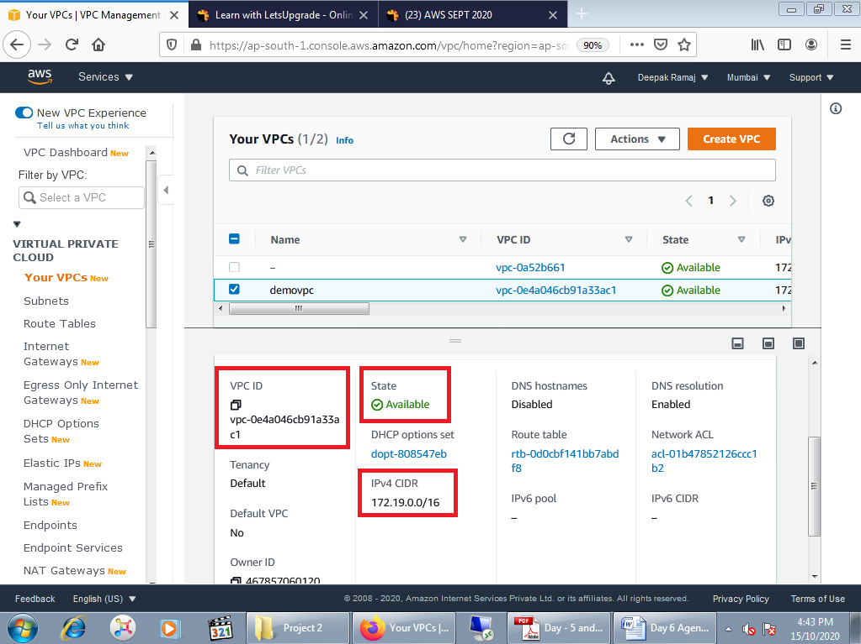

Fig. 2.1 VPC Dashboard

**Task 2:** Create an Internet gateway

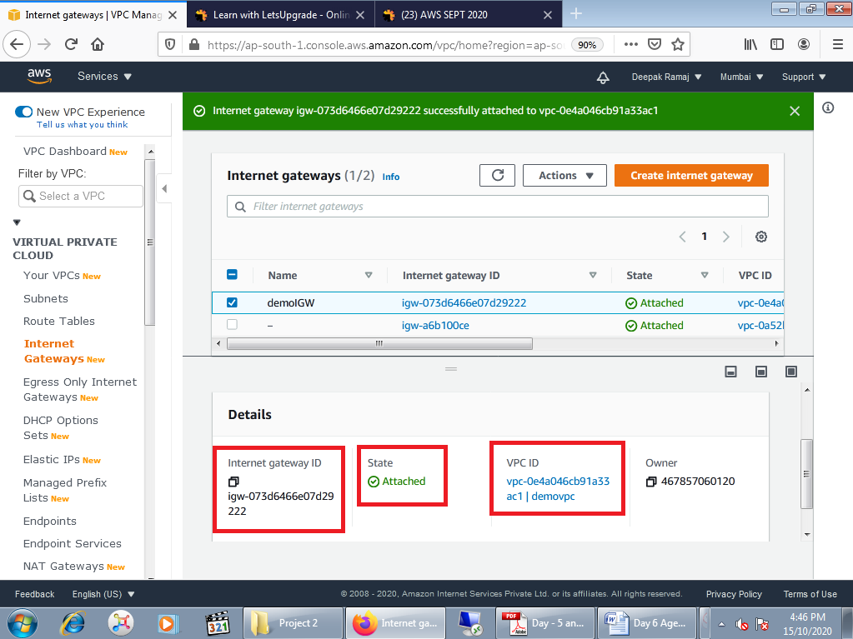

Fig. 2.2 Internet Gateway Dashboard

**Task 3:** Create a route table

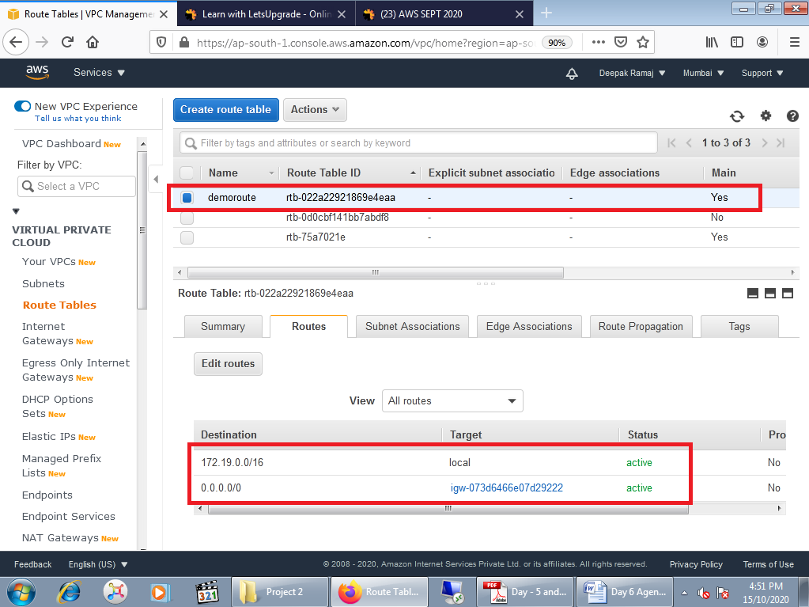

Fig. 2.3 Route Table

**Task 4:** Create a subnet

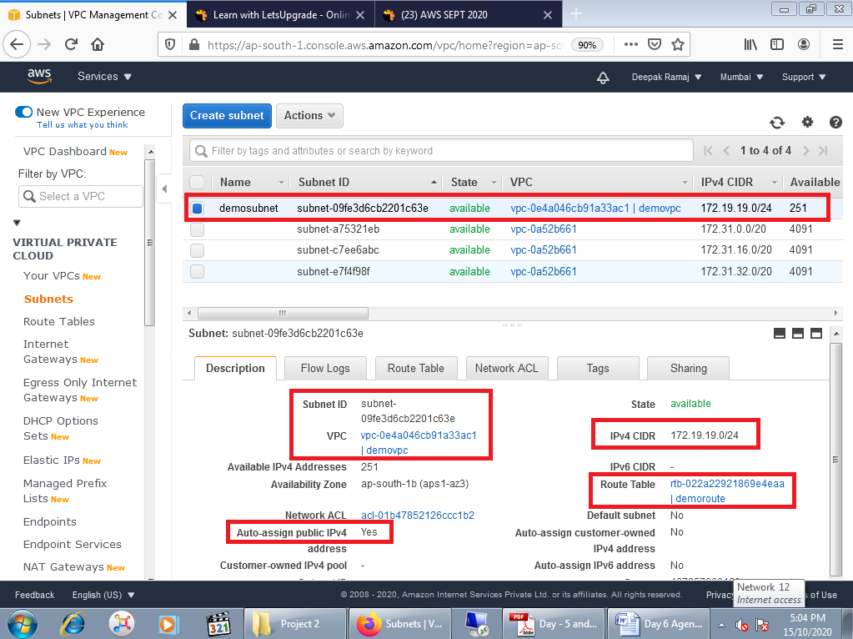

Fig. 2.4 Subnet Dashboard

**Task 5:** Create an EC2 in custom vpc

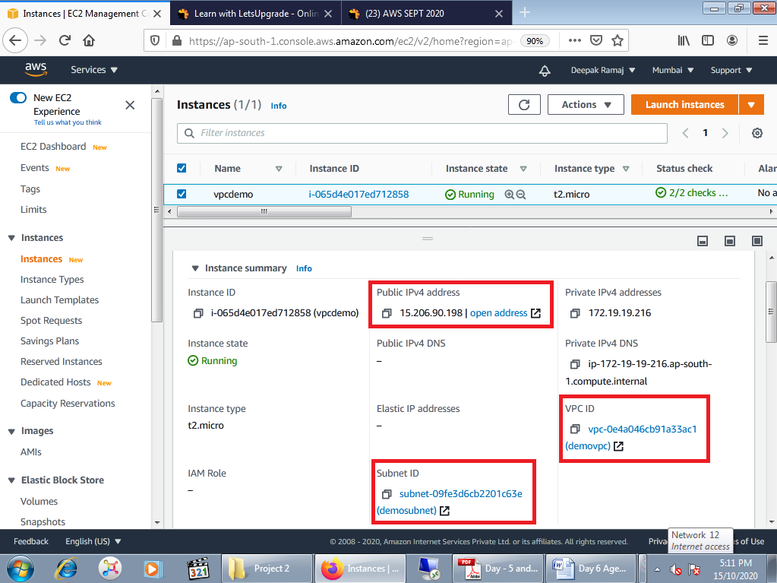

Fig. 2.5 EC2 Dashboard

**Task 6:** Check ipconfig in VM command prompt

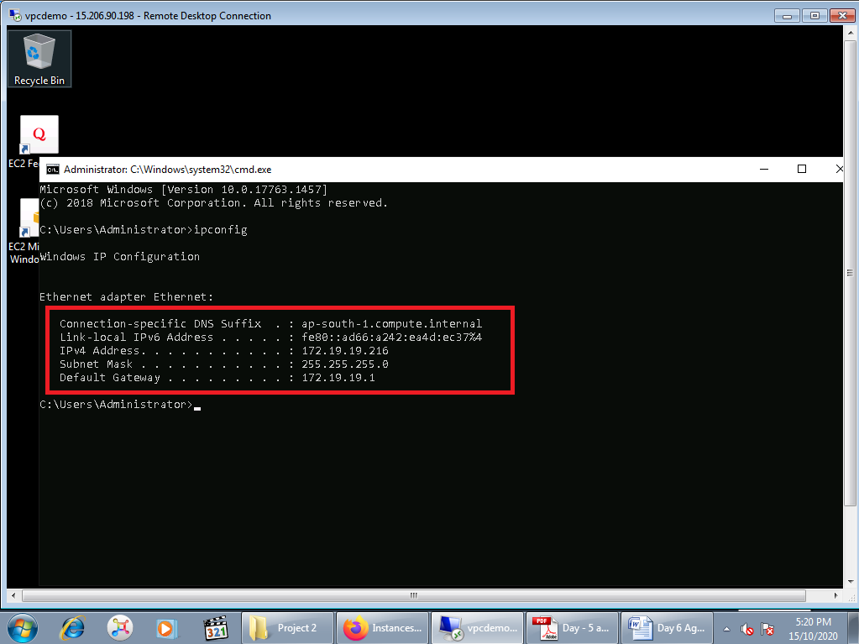

Fig. 2.6ipconfig command